

|  |
| --- |
| **MATHEMATICS DEPARTMENT**  **Year 11 Specialist – 2016**  **Test Number 2: Mathematical Proof**  **Resource Free** |

**Name: _______________________________________ Teacher: DDA**

**Marks: 39**

**Time Allowed: 40 minutes**

**Weight: 3.5%**

**Instructions:** You **ARE** **NOT** permitted any notes or calculator. Show your working where appropriate remembering you must show working for questions worth more than 2 marks.

_________________________________________________________________________

1 Consider the statements:

I   If you have a driver’s licence then you are over 16.

II If you are not over 16 then you do not have a driver’s licence.

Which of the following is true?

A  II is the converse of I.

B II is the contrapositive of I.

C II is a counterexample of I.

D II is the negative of I.

E  II is the reverse of I.

[1 mark]

2 Consider the argument:

All fish live in water.

A turtle lives in water.

Therefore a turtle is a fish.

The argument is:

A   a contrapositive

B  inductive

C a contradiction

D  invalid

E a counterexample.

[1 mark]

3 If  Description: symb3  is true then which statement is true?

A  P Description: symb3 Q

B P Description: symb2 Q

C Q Description: symb3 P

D Q Description: symb2 P

E   Description: symb3 

[1 mark]

4 The values x = 3, y = −2 would be a counterexample to which of the following?

A x > y Description: symb3 x2 > y2

B x > y Description: symb3 

C x > y Description: symb3 xy > y2

D x > y Description: symb3 x2 > xy

E  x > y Description: symb3 

[1 mark]

5 You would use the SAS test to prove which pair of triangles congruent? (Circle the correct answer)

A 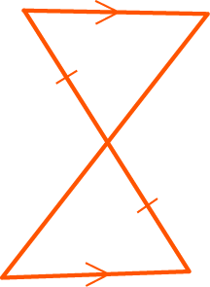

B 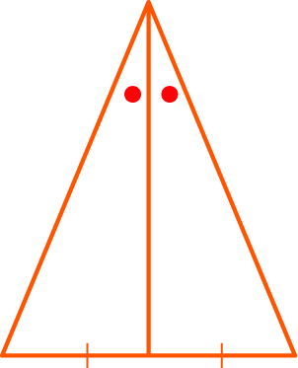

C 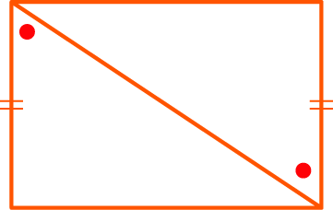

D 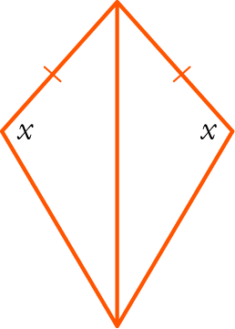

E   None of the above.

[1 mark]

6 Write the statement below using mathematical notation.

For all rational numbers x there exist integers p and q where q is non-zero such that .

|  |
| --- |
|  |
|  |

[3 marks]

7 For the statement:

If you drink too much alcohol then you will get alcohol poisoning.

a  Write the converse.

|  |
| --- |
|  |
|  |

b   Write the inverse.

|  |
| --- |
|  |
|  |

c  Is the statement an equivalence? Give reasons.

|  |
| --- |
|  |
|  |

[4 marks]

8 Consider the two premises:

P: A quadrilateral is a rhombus.

Q: A quadrilateral has diagonals that bisect each other at right angles.

a Write P Description: symb3 Q.

|  |
| --- |
|  |
|  |

b Write Q Description: symb3 P.

|  |
| --- |
|  |
|  |

c Is it true that P Description: symb2 Q? If so, write a statement linking P and Q using iff.

True or False? __________

|  |
| --- |
|  |
|  |

[3 marks]

9 Complete the proof that  is irrational.

|  |
| --- |
| Proof: Assume that  is rational, i.e. ∃ m, n ∈ Z, n ≠ 0 such that, |
| where m, n have no common factors. |
| Then squaring both sides: 2 = |
|  |
|  |
|  |
|  |
|  |
|  |
|  |
|  |
| ∴ is irrational. |

[6 marks]

10 For each statement below, consider the contrapositive statement to determine whether or not the statement is true. Justify your reasoning.

a If pensioners have electronic devices then they send emails.

|  |
| --- |
| Contrapositive: |
|  |
|  |
|  |
|  |
|  |

b If a number is divisible by 4 then it is even.

|  |
| --- |
| Contrapositive: |
|  |
|  |
|  |

[5 marks]

11 In the diagram, AB ⊥ AC, AD ⊥ BC, BD = 4, DC = 9, AD = x.

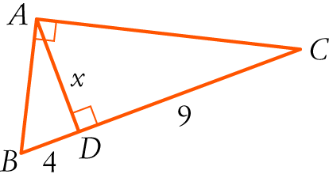

a Prove that Δ ABD ||| Δ CAD. Make you justify every line with a reason or rule.

|  |
| --- |
| In $∆ABD$ and $∆CAD$: |
| = ( ) |
| = ( ) |
|  |
| $∴$ ( ) |

b Hence find the value of x.

|  |
| --- |
|  |
|  |
|  |
|  |
|  |

[6 marks]

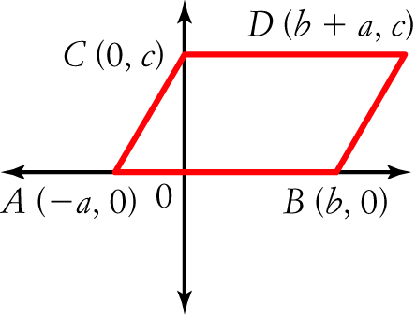

**12** Consider the diagram with coordinates (−a, 0), (b, 0), (0, c), (b + a**,** c) representing the points A, B, C, D respectively, such that ABDC is a parallelogram.

a Determine the length of each of the following in terms of $a,b$ and $c$.

|  |  |
| --- | --- |
| *AB =* | *CD =* |
| *AC =* | *BD =* |
| *AD =* | *BC =* |

**b** Hence, write an expanded expression for each of the following in terms of $a,b$ and $c$.

**i)** AB2 + DB2 + DC2 + CA2

|  |
| --- |
|  |
|  |

ii) AD2 + CB2

|  |
| --- |
|  |
|  |

c What property of a parallelogram does this demonstrate?

|  |
| --- |
|  |
|  |

[7 marks]